**NAME: SHASVAT NIMESH SHAH**

**SAP ID: 60004220126**

**DIV: B**

**TOPIC:** DE

**Experiment Number:** 6

**DATE:**

**AIM:**

To study MUX and DEMUX IC’s. Realize 16:1 MUX using 8: 1 MUX.

**APPARATUS:**

ICs (74151) , D.C. Power supply (5V), Red/Green LEDs (1 Nos), Connecting wires, Breadboard.

**THEORY:**

The function of a multiplexer is to select the input of any ‘n’ input lines and feed that to one output line. The function of a de-multiplexer is to inverse the function of the multiplexer and the shortcut forms of the multiplexer.

MULTIPLEXER: Multiplexer is a device that has multiple inputs and a single line output. The select lines determine which input is connected to the output, and also increase the amount of data that can be sent over a network within a certain time. It is also called a data selector.

4X1 MULTIPLEXER : 4x1 Multiplexer has four data inputs I3,I2, I1&I0,two selection linesS1&S0 and one output Y. The block diagram of 4x1Multiplexer is shown in the following figure. One of these 4 inputs will be connected to the output based on the combination of inputs present at these two selection lines.

DEMULTIPLEXER:

De-multiplexer is also a device with one input and multiple output lines. It is used to send a signal to one of the many devices. The main difference between a multiplexer and a de-multiplexer is that a multiplexer takes two or more signals and encodes the mona wire, whereas a de-multiplexer does reverse to what the multiplexer does.

1X4 DEMULTIPLEXER :1x4 De-Multiplexer has one input I, two selection lines, S1 & S0 and four outputs Y3, Y2, Y1 &Y0. The block diagram of 1x4 De-Multiplexer.

**PROCEDURE:**

1. Place the IC on IC Trainer Kit.

2. Connect VCC and ground to respective pins of IC Trainer Kit.

3. Implement the circuit as shown in the circuit diagram.

4. Connect the inputs to the input switches provided in the IC Trainer Kit.

5. Connect the outputs to the switches of O/P LEDs

6. Apply various combinations of inputs according to the truth table and observe the condition of LEDs.

7. Note down the corresponding output readings for various combinations of inputs.

8. Power Off Trainer Kit, disconnect all the wire connections and remove IC's from IC-Base

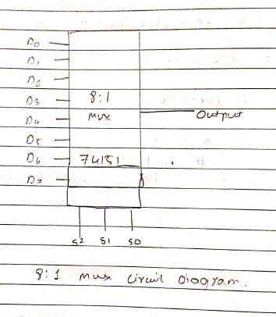

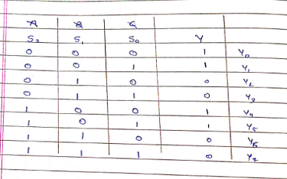

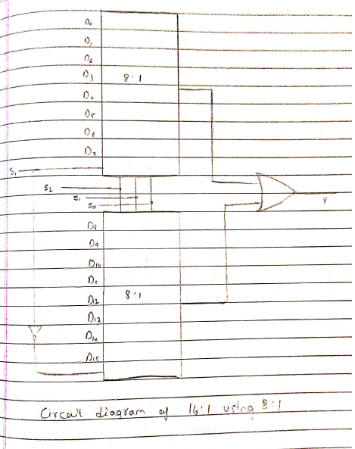

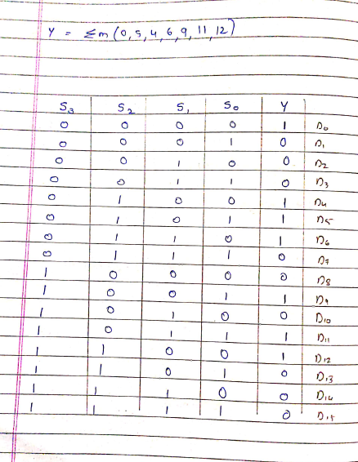

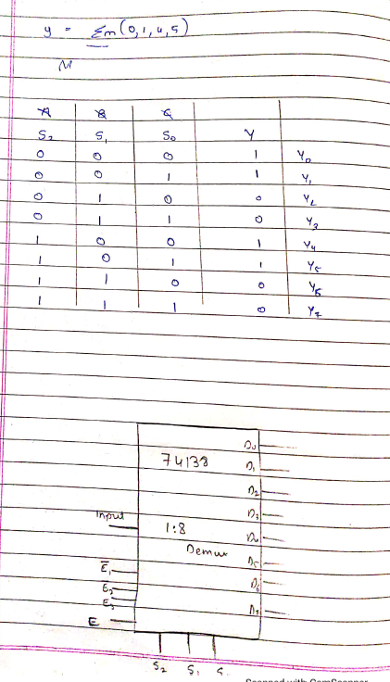

**CONCLUSION:** Hence, we have got all the concepts of mux, demux ic’s and have realized 16:1 mux using 8:1 mux.